Project Documentation
Heart Disease Analysis Dashboard using Tableau
Step 1: Project Selection
Description
The project selected for this internship is Heart Disease Analysis using Tableau. The main objective is to analyse healthcare data and identify the factors contributing to heart disease through interactive visualizations.
Output:
- Project topic finalized.
- Objectives identified.

Step 2: Dataset Collection
Description
The Heart Disease 2020 dataset was collected. The dataset contains patient demographic details, lifestyle information, and medical conditions.
Dataset Fields
- HeartDisease
- BMI
- Smoking
- Alcohol Drinking
- Stroke
- Physical Health
- Mental Health
- Sex
- Age Category
- Race
- Diabetic
- Physical Activity
- General Health
- Sleep Time
- Asthma
- Kidney Disease
- Skin Cancer
Output:
Dataset ready for analysis.
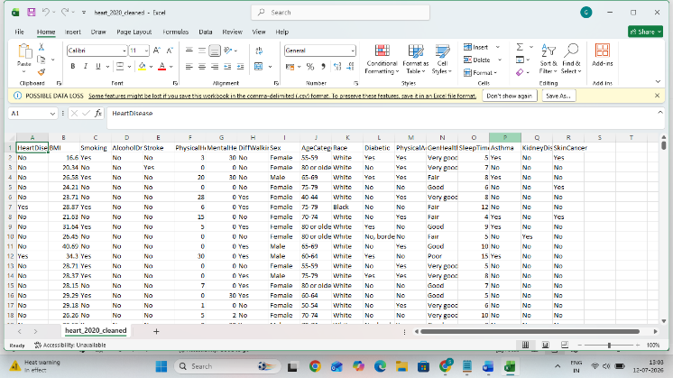
Step 3: Import Dataset into Tableau
Procedure
- Open Tableau Desktop.
- Click Connect.
- Select Text File.
- Choose the Heart Disease dataset.
- Verify all fields.
- Click Sheet 1.
Output
Dataset successfully imported into Tableau.
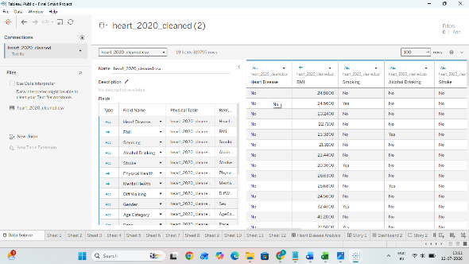
Step 4: Data Preparation
Procedure
The imported data was verified before visualization.
The following checks were performed:
- Checked Null Values
- Verified Data Types
- Renamed Columns if required
- Classified Dimensions
- Classified Measures
Dimensions
- Age Category
- Gender
- Smoking
- Diabetes
- General Health
Measures
- BMI
- Physical Health
- Mental Health
- Sleep Time
Output
Clean dataset prepared.
Step 5: Create Worksheet 1
Gender vs Heart Disease
Procedure
- Open Worksheet.
- Drag Heart Disease into Columns.
- Drag Number of Records into Rows.
- Create a Bar Chart.
- Add Labels.
Output
Heart Disease distribution chart created.
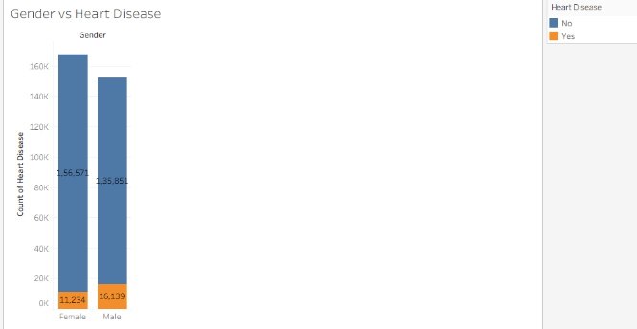

Step 6: Create Worksheet 2
Age vs Heart Disease
Procedure
- Drag Age Category to Columns.
- Drag Number of Records to Rows.
- Filter using Heart Disease.
- Apply colors.
Output
Age-wise heart disease analysis completed.
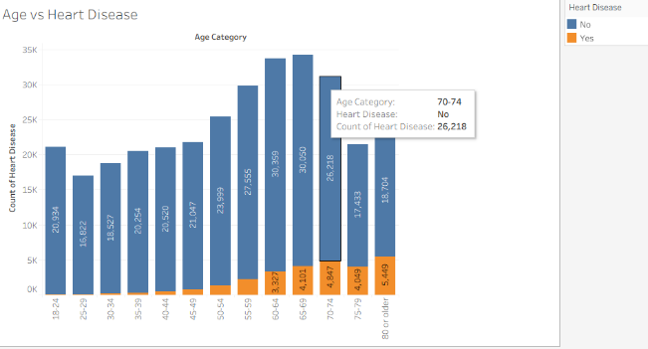
Step 7: Create Worksheet 3
Diabetic vs Stroke
Procedure
- Drag Sex into Columns.
- Drag Number of Records into Rows.
- Color by Heart Disease.
- Add Labels.
Output
Diabetic vs Stroke chart created.
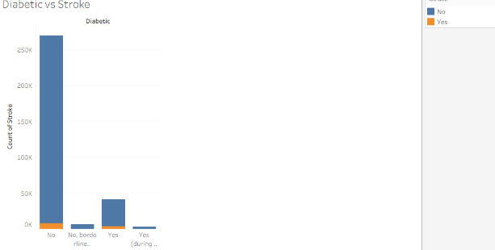

Step 8: Create Worksheet 4
Impact of smoking and alcohol on heart disease
Procedure
- Drag Smoking into Columns.
- Drag Heart Disease Count into Rows.
- Apply Filters.
- Format the chart.
Output
Smoking and Alcohol impact analyzed.
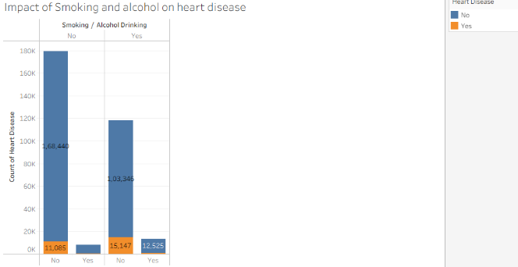
Step 9: Create Worksheet 5
BMI Analysis
Procedure
- Drag BMI.
- Create Histogram.
- Compare with Heart Disease.
Output
BMI distribution created.
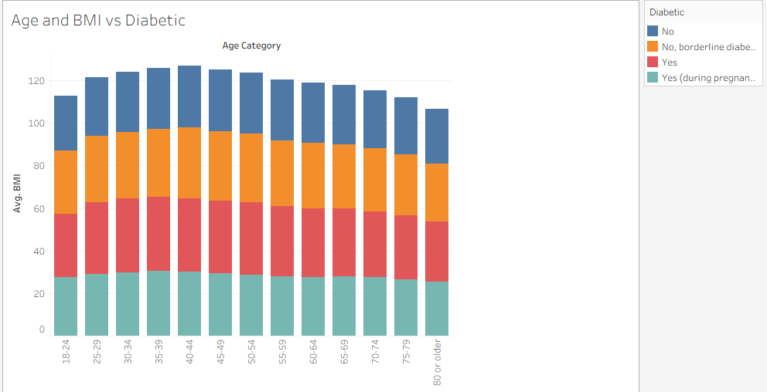

Step 10: Create Worksheet 6
Diabetes Analysis
Procedure
- Drag Diabetes.
- Compare with Heart Disease.
- Use Bar Chart.
Output
Diabetes relationship identified.
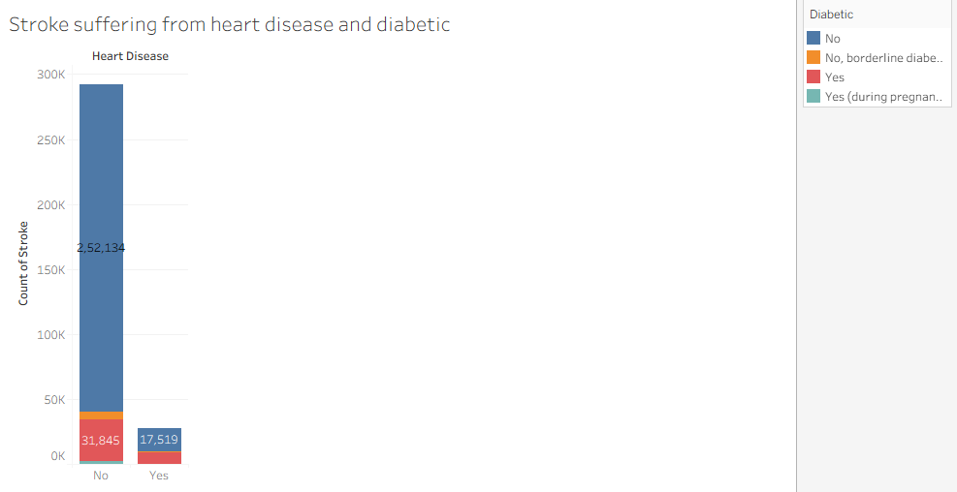

Step 11: Create Dashboard
Procedure
- Click New Dashboard.
- Set Dashboard Size.
- Drag all Worksheets into Dashboard.
- Arrange Charts.
- Add Dashboard Title.
- Add Filters.
- Enable Interactive Actions.
Output
Interactive dashboard completed.
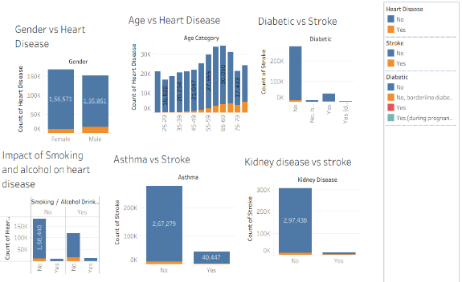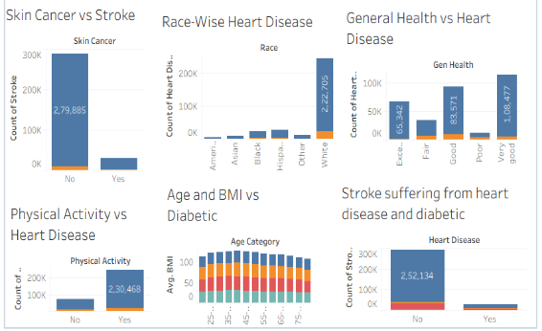
Step 12: Create Story
Procedure
- Click New Story.
- Add Dashboard.
- Create Story Points.
- Add Captions.
- Explain Findings.
Output
Story successfully created.
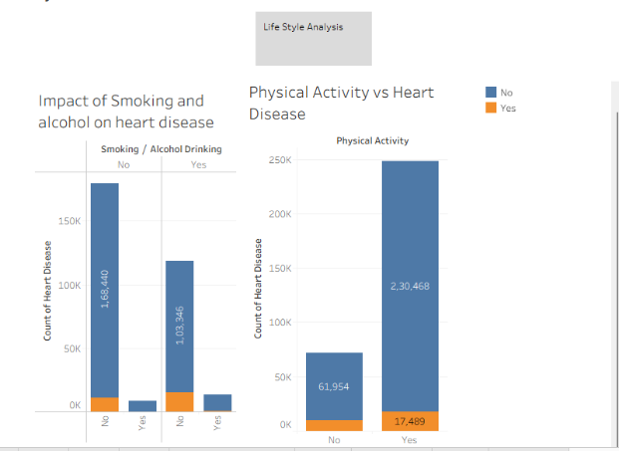

Step 13: Dashboard Testing
Procedure
The dashboard was tested using:
- Filter Selection
- Highlight Actions
- Navigation
- Dynamic Updates
The dashboard responded correctly to all interactions.

Step 14: Results
The analysis identified several key findings:
- Older age groups have higher heart disease prevalence.
- Smokers are more likely to have heart disease.
- Diabetes significantly increases heart disease risk.
- Poor general health is associated with a higher incidence of heart disease.
- Physical activity is linked to a lower risk of heart disease.

Step 15: Conclusion
The Heart Disease Analysis Dashboard was successfully developed using Tableau. The dashboard transforms raw healthcare data into meaningful visual insights, allowing users to explore patterns, compare health indicators, and support informed healthcare decisions through interactive visualizations.

